**Mechanical Interface**

M.J. McNally

|  |  |  |
| --- | --- | --- |
| Date | Updated Reference Number | change |
|  |  |  |
| 04/10/2009 | PLM-COMS-MecInter-133-1 | Uploaded in new format |
|  |  |  |
|  |  |  |
|  |  |  |
|  |  |  |

**Components :**

Transceiver :

|  |  |  |  |  |
| --- | --- | --- | --- | --- |
|  | Mass (g) | Width (mm) | Depth (mm) | Height (mm) |
| LRT 470 | 120 | 78 | 52 | 20 |

This must be attached to

Transceiver/Modem PCB:

|  |  |  |  |
| --- | --- | --- | --- |
| Width (mm) | Depth (mm) | Height (mm) | Mass (g) |
| 50 | 50 | ~10 | ~20 |

This is based on the size of the test board PCB layout. Alternative layouts are possible.

Antenna Cables:

The signal output from the transceiver must be sent to the antennas by two impedance matched coaxial cables. The recommended model (from Jan King link budget calculator) is the RG-188/AU micro-coaxial cable, although many alternatives with similar dimensions are available.

|  |  |  |
| --- | --- | --- |
| Length (mm) | Diameter (mm) | Mass (g) |
| 100 | 2.8 | 1.4 |

I have suggested a cable length of 100mm here as this should allow the cable to reach the antenna mounting points at the corners of the cubesat regardless of where the COMS board is placed in the body of the satellite. This is an approximation to give some idea of the mass and size. The most important point to note is that these cables must be impedance matched to ensure that the signals reaching each antenna are identical. The simplest way to achieve this is to have two identical lengths of the same cable.

Additional components:

|  |  |  |  |  |
| --- | --- | --- | --- | --- |
| Component | Mass (approx) (g) | Width (mm) | Depth (mm) | Height (mm) |
| Coaxial T-junction | 2 | 10 | 5 | 5 |
| Coaxial connector x2 | 1 | 5 | 5 | 5 |

Antenna:

Each antenna requires an external mounting, as well as a deployment mechanism inside the satellite.

|  |  |  |  |
| --- | --- | --- | --- |
|  | Mass (g) | Length (mm) | Width (mm) |
| Antenna | 8.8 | 170 | 7 |

Release mechanism:

|  |  |  |  |  |
| --- | --- | --- | --- | --- |
| Component | Mass (g) | Width (mm) | Depth (mm) | Height (mm) |
| Nichrome Coil | 2.6 | 20 | 5 | 5 |
| Heat Pad | ~20 | 40 | 40 | 2 |
| Control Circuit | ~5 | ~20 | ~20 | ~5 |

Antenna Deployment Positioning:

When folded against the cubesat, antenna will be held in place by fishing line. As can be seen from the board schematic below, there is not enough space on the COMS board for the antenna deployment mechanisms. Ideally the deployment mechanisms should be as close to the antennas as possible, in order to minimize the amount of loose fishing line inside the body of the satellite. This suggests that two deployment mechanisms will be needed. Until the deployment mechanism has been tested it is impossible to give exact locations, orientations and sizes of the deployment mechanisms. However as a rough guide, the diagram below shows how far the antenna will wrap around the body of the satellite. [Seek advice from MEC on the best alignment to fit deployers in with other boards: i.e. should they be fitted flat on the upper and lower surfaces, with either board clearance or a plan cutout, or should they be on the side walls, with profile cutouts to fit]



COMS Board Schematic [To Scale]:

Shaded blue region = space for PIC modem and control circuit [including antenna release]

The Tx Out connector on the Transceiver is represented by the black dot.

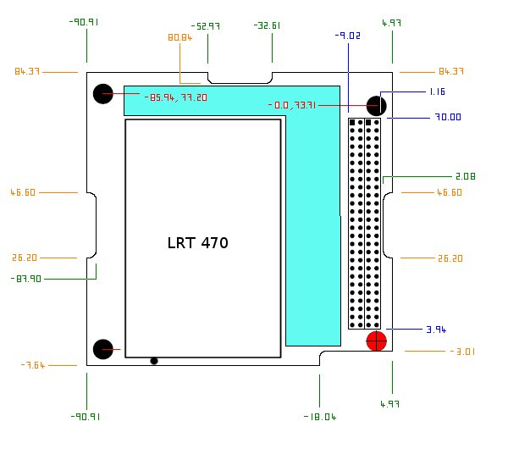N.B. LRT & LRC manual states that the box is sufficiently insulated for circuitry to run beneath it. This allows us considerable additional space.